**SDG&E® RESIDENTIAL AND SMALL BUSINESS CONTENT PACKAGE | JUNE 2024**

As a trusted community partner, we thank you for sharing our content and digital assets with your audiences – including residents, customers and employees – to help amplify our key messages in your email communications, websites or newsletters.

**Best practices for using our content, social media posts and images**

1. **IMAGES**

Choose IMAGES that are relevant for your audience and feel free to mix and match what we provide. For alternate images, [***Unsplash.com***](https://unsplash.com/) and [***Canva.com***](https://www.canva.com/photos/free/) offer free images that you can download.

1. **SDG&E logo**

You’re welcome to mention our name but, due to legal requirements, please do not use our logo in any marketing materials that you create. Please only use the SDG&E logo if we provide it to you in this package or it’s publicly available online like a social post or video. You can also retweet our public posts which you’ll find on [***facebook.com/sdge***](https://www.facebook.com/search/top?q=san%20diego%20gas%20%26%20electric) and [***twitter.com/sdge***](https://twitter.com/sdge).

1. **Videos**

We have a library of videos you can share in your communications and SOCIAL POSTS when you visit [[***youtube.com/c/SanDiegoGasElectric/videos***](https://www.youtube.com/c/SanDiegoGasElectric/videos)](https://www.youtube.com/c/SanDiegoGasElectric/videos). If you’d like to sort our videos by topic, visit [***youtube.com/c/SanDiegoGasElectric***](https://www.youtube.com/c/SanDiegoGasElectric). Some videos are in Spanish. You’ll see some on TV, too!

**Follow us**

Find us on [**Facebook**](https://www.facebook.com/SanDiegoGasandElectric)**,** [**Instagram**](https://www.instagram.com/sdge)**,** [**Twitter**](https://twitter.com/SDGE)**,** [**YouTube**](https://www.youtube.com/sandiegogaselectric)and[**LinkedIn**](http://linkedin.com/company/sdge). When sharing our digital assets and content, feel free to tag SDG&E’s social media and direct your audience to [***sdge.com***](https://www.sdge.com).

**This month’s topics:** Pre-owned EV rebate program, start/stop/move, ELRP program for businesses, Res and Bus energy-saving tips, assistance programs

**ARTICLE: CUT COSTS ON YOUR SUMMER ENERGY BILL**

Warmer temps are on their way, but it doesn’t have to mean higher energy bills. Use major appliances when energy is less expensive, before 4 p.m. or after 9 p.m. Here are ways to save energy and money while staying cool.

First, let’s talk about appliances. They tend to use a lot of energy and heat up your home at the same time. With that in mind, consider the following:

1. Change the way you cook: Turn off the oven and stovetop as much as possible. Relying on microwaves, slow cookers, backyard grills or air fryers are great ways to heat up your food but not your home. If you’re going to use your oven, do it sparingly and during the coolest part of the day.
2. Change how you wash your clothes: Use cold water to wash your clothes so you don’t have to pay to heat the water. Cold water helps reduce wrinkles and remove stains. Washing in cold also helps your clothes last longer, prolong vibrancy and maintain their shape and size. Always aim for full loads of laundry and consider line drying them.
3. Don’t “heat dry” your dishes: When running your dishwasher, turn off the “heat dry” cycle and let dishes air dry instead.
4. Use smart plugs for appliances: Smart plugs allow you to schedule when your appliances are on or off – even remotely. They also help reduce “vampire draw” since appliances still use energy when they’re off but still plugged in.

Beyond appliances, here are other great ways to save on energy use:

1. Save with Golden State rebates: Receive rebates toward the purchase of energy-efficient products like smart thermostats, heat pump water heaters and room air conditioners. Get details at [***sdge.com/rebates***](https://www.sdge.com/rebates)and for the product list, visit [***GoldenStateRebates.com***](https://goldenstaterebates.clearesult.com/browse-products).
2. Use ceiling fans instead of the A/C: Ceiling fans can save up to 25 percent on cooling costs and reduces your home’s temperature up to ten degrees. In warmer temps, fans should be set counter-clockwise for the best cooling effect. Don’t forget to change the direction to clockwise when temps drop in cooler months because the fan pushes heat down.
3. Use occupancy sensors: Install occupancy sensors for your lights. These sensors automatically turn off lights when there’s no movement in a room. [You can also opt for dimmer switches with occupancy sensors to adjust lighting levels based on need](https://www.bhg.com/home-improvement/green-living/energy-efficient/home-energy-savings/).
4. Cook efficiently: Use lids on pots and pans while cooking to retain heat. Match the pot size to the burner to avoid energy waste.

For more ideas on how to save energy, visit [***sdge.com/MyEnergy***](https://www.sdge.com/energy-management-summer).

**SOCIAL POSTS: CUT COSTS ON YOUR SUMMER ENERGY BILL**

Use any bullet above and then add: For more energy-saving tips, visit [***sdge.com/MyEnergy***](https://www.sdge.com/energy-management-summer). #sdge #SDGEassist

**IMAGES: CUT COSTS ON YOUR SUMMER ENERGY BILL**



**article: GET UP TO $4,000 TOWARDS A USED EV**

Driving electric just got more affordable with SDG&E’s new Pre-Owned Electric Vehicle (EV) Rebate Program that rewards qualifying customers with rebates of up to $4,000 when you buy or lease a used EV. Vehicles purchased after January 1, 2024, qualify for the program. Don’t miss out on your chance to save on driving costs while contributing to a cleaner, healthier environment. To learn more or apply, visit [***EVRebates.sdge.com***](https://evrebates.sdge.com/).

**article (translated): Recibe Hasta $4,000 para un VE Usado**

Conducir un vehículo eléctrico (VE) ahora es más económico con el nuevo Programa de reembolso de vehículos usados de SDG&E que recompensa a los clientes que califiquen con un crédito de hasta $4,000 cuando compren o arrenden un VE. Los vehículos comprados después del 1 de enero del 2024 califican para este programa. No pierdas la oportunidad de ahorrar en costos de combustible y al mismo tiempo contribuir a un medio ambiente más limpio y sano. Para más información, visita [***EVRebates.sdge.com***](https://evrebates.sdge.com/).

**social posts: GET UP TO $4,000 TOWARDS A USED EV**

1. Qualifying SDG&E customers could receive a $1,000 or $4,000 rebate when buying or leasing an eligible pre-owned battery electric vehicle or plug-in hybrid vehicle. See program requirements at [***EVRebates.sdge.com***](https://evrebates.sdge.com/). #sdge #SDGEassist
2. Are you thinking about buying an electric vehicle? SDG&E offers a variety of tools, rebates and resources. ***Learn more at*** [***sdge.com/Lovelectric***](https://www.sdge.com/residential/lovelectric). #sdge #SDGEassist
3. Wondering what your cost savings would be if you bought an electric car? Check out SDG&E’s [EV Savings Calculator](https://ev.sdge.com/savingscalculator) at [***ev.sdge.com/SavingsCalculator***](https://ev.sdge.com/savingscalculator).

**images: GET UP TO $4,000 TOWARDS A USED EV**

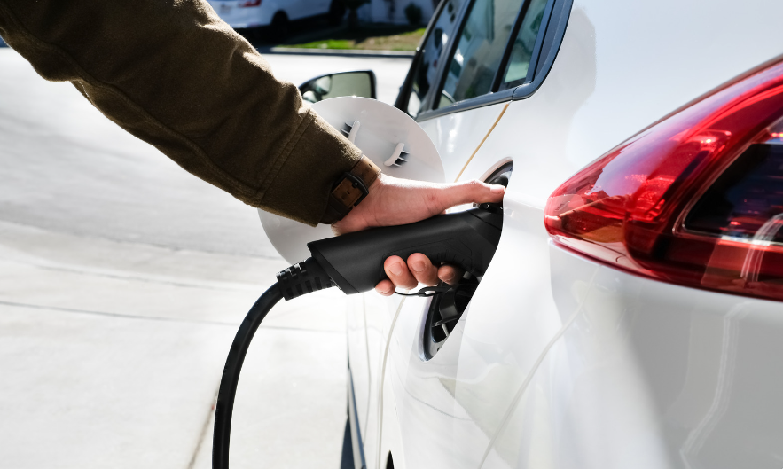

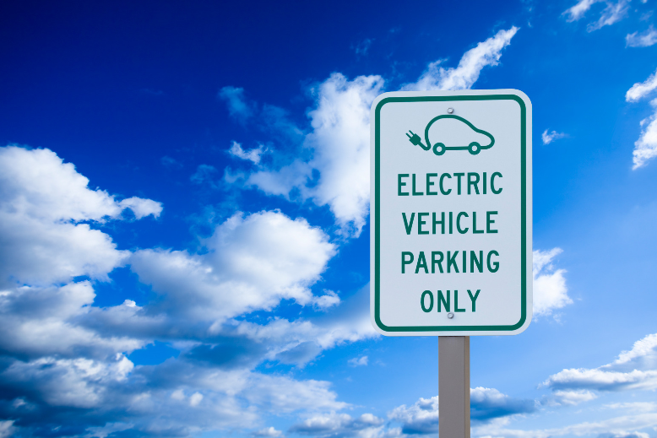

**ARTICLE: MOVING? SCHEDULE YOUR SDG&E SERVICE REQUEST ONLINE**

Take some stress out of your move when you schedule your SDG&E service request online. Use SDG&E’s My Account to start, transfer or stop your service. It’s easy and only takes a minute. No need to call and no need to wait on the phone. Online scheduling shows you available dates that you can choose. If your plans change, simply update your request online. Cross one more thing off your to-do list! Get more information at [***sdge.com/move***](https://www.sdge.com/residential/customer-service/service-requests/start-stop-move).

**SOCIAL POSTS: MOVING? SCHEDULE YOUR SDG&E SERVICE REQUEST ONLINE**

1. Moving? Make moving easier with online scheduling tools. Visit [***sdge.com/move***](https://www.sdge.com/residential/customer-service/service-requests/start-stop-move) to start, transfer or stop your SDG&E service. #sdge #SDGEassist
2. Moving made easy. Start, transfer or stop your SDG&E service online. Easy, convenient – no calls, no waiting. Get more information at [***sdge.com/move***](https://www.sdge.com/residential/customer-service/service-requests/start-stop-move). #sdge #SDGEassist

**IMAGES: MOVING? SCHEDULE YOUR SDG&E SERVICE REQUEST ONLINE**





**ARTICLE: NEED HELP WITH YOUR ENERGY BILL?**

If you are having trouble paying your energy bill, you might be eligible for programs and services that can provide immediate financial assistance and help you avoid interruptions to your service. Flexible payment arrangements are also available to help you pay down past due balances. Learn more at [***sdge.com/Payment-Arrangements***](https://www.sdge.com/residential/pay-bill/payment-arrangements).

Check out these energy assistance programs:

* California Alternate Rates for Energy (CARE) Program: Save 30% or more every month on your bill. Find out if you qualify at [***sdge.com/CARE***](https://www.sdge.com/residential/pay-bill/get-payment-bill-assistance/assistance-programs).
* Family Electric Rate Assistance (FERA) Program: If you do not qualify for CARE and your household has three or more people, you may qualify for FERA. You could receive an 18% discount on your electric bill. Visit [***sdge.com/FERA***](https://www.sdge.com/FERA) to learn more.
* Energy Savings Assistance (ESA) Program: You may qualify to receive free energy-saving improvements for your home, like new appliances, lighting, insulation and more. Find details at [***sdge.com/ESA***](https://www.sdge.com/residential/pay-bill/get-payment-bill-assistance/assistance-programs/no-cost-energy-efficient-home-improvements).
* Arrearage Management Plan (AMP): If you have outstanding bills and you are a CARE or FERA customer, you may be eligible for debt forgiveness. See if you qualify at [***sdge.com/AMP***](https://www.sdge.com/residential/pay-bill/get-payment-bill-assistance/amp).

Even if you made a recent payment or set up a flexible payment plan with SDG&E, there may still be assistance programs available to help you. For a complete list of available offerings, visit  [***sdge.com/assistance***](https://www.sdge.com/residential/pay-bill/get-payment-bill-assistance).

**SOCIAL POSTS: NEED HELP WITH YOUR ENERGY BILL?**

1. If you are behind on your energy bill, you may qualify for financial assistance. Learn more at [***sdge.com/assistance***](https://www.sdge.com/residential/pay-bill/get-payment-bill-assistance). #sdge #SDGEAssist
2. Hardship can hit at any time – when it does, the last thing you need to worry about is your energy bill. Get help with your bill at [***sdge.com/assistance***](https://www.sdge.com/residential/pay-bill/get-payment-bill-assistance). #sdge #SDGEAssist
3. SDG&E provides assistance programs to help you with your monthly energy bill which can include up to a 30% discount. Find out if you qualify at [***sdge.com/assistance***](https://www.sdge.com/residential/pay-bill/get-payment-bill-assistance). #sdge #SDGEAssist
4. Whether you rent or own, you could be eligible to receive no-cost, energy-efficient home improvements that can make your home more comfortable and help reduce your energy bill. Find out if you qualify at [***sdge.com/ESA***](https://www.sdge.com/residential/pay-bill/get-payment-bill-assistance/assistance-programs/no-cost-energy-efficient-home-improvements). #sdge #SDGEAssist

**ARTICLE (translated): ¿NECESITA AYUDA CON SU FACTURA DE ENERGÍA?**

Usted puede calificar para un descuento en su factura o mejoras en el hogar. Hay programas de asistencia que pueden ayudar a reducir su factura mensual de energía mientras mantiene su hogar cómodo.

* Programa de Tarifas Alternativas de Energía de California (CARE, por sus siglas en inglés): Ahorre un 30% o más cada mes en su factura. Averigüe si califica en [***sdge.com/CAREesp***](https://www.sdge.com/residential/pay-bill/get-payment-bill-assistance/assistance-programs#googtrans(en|es)).
* Tarifa Eléctrica Familiar (FERA, por sus siglas en inglés): Si no califica para CARE y su hogar tiene 3 o más personas, puede calificar para FERA. Podría recibir un 18% de descuento en su factura de electricidad. Visite [***sdge.com/FERAesp***](https://www.sdge.com/FERA#googtrans(en|es))para obtener más información.
* Programa de Asistencia para el Ahorro de Energía (ESA, por sus siglas en inglés): Puede calificar para recibir mejoras gratuitas para el ahorro de energía en su hogar, tales como electrodomésticos nuevos, iluminación, aislamiento y más. Encuentre los detalles en [***sdge.com/ESAesp***](https://www.sdge.com/residential/pay-bill/get-payment-bill-assistance/assistance-programs/no-cost-energy-efficient-home-improvements#googtrans(en|es)).
* Arrearage Management Plan (AMP): Si tiene facturas pendientes y es participante en el programa de CARE o FERA, puede ser elegible para la condonación de deudas. Averigüe si califica en [***sdge.com/AMPesp***](https://www.sdge.com/residential/pay-bill/get-payment-bill-assistance/amp#googtrans(en|es)).

Las aplicaciones en línea son fáciles, rápidas y convenientes. Para obtener más información, visite [***sdge.com/asistencia***](https://www.sdge.com/residential/pay-bill/get-payment-bill-assistance#googtrans(en|es)).

**Publicaciones para compartir en las redes sociales: ¿NECESITA AYUDA CON SU FACTURA DE ENERGÍA?**

1. Si está atrasado en su factura de energía, puede calificar para asistencia financiera. Obtenga más información en [***sdge.com/asistencia***](https://www.sdge.com/residential/pay-bill/get-payment-bill-assistance#googtrans(en|es)). #sdge #SDGEAssist
2. Dificultades pueden aparecer en cualquier momento – si aparecen, lo último que necesita es preocuparse por su factura de energía. Obtenga ayuda con su factura en [***sdge.com/asistencia***](https://www.sdge.com/residential/pay-bill/get-payment-bill-assistance#googtrans(en|es)). #sdge #SDGEAssist
3. SDG&E ofrece programas de asistencia para ayudarle con su factura mensual que puede incluir hasta un 30% de descuento. Descubra si califica en [***sdge.com/asistencia***](https://www.sdge.com/residential/pay-bill/get-payment-bill-assistance#googtrans(en|es)). #sdge #SDGEAssist
4. Si alquile o es propietario, podría ser elegible para recibir mejoras de eficiencia energética en su hogar, sin costo, que pueden hacer que su hogar sea más cómodo y ayuden reducir su factura de energía. Descubra si califica en [***sdge.com/ESAesp***](https://www.sdge.com/residential/pay-bill/get-payment-bill-assistance/assistance-programs/no-cost-energy-efficient-home-improvements#googtrans(en|es)). #sdge #SDGEAssist

**IMAGES: NEED HELP WITH YOUR ENERGY BILL?**





**ARTICLE: WOULD YOUR BUSINESS ENJOY LOWER ENERGY BILLS?**

Higher summer temperatures can mean higher energy bills and cause an extraordinary strain on the electrical grid. This can lead to a greater risk of grid emergencies and power outages. But it doesn't have to be this way.

During a grid emergency, businesses in SDG&E's service territory can participate in the Emergency Load Reduction Program (ELRP). By joining ELRP, businesses help support the grid when it's facing extra strain and can get a bill credit for their participation. ELRP is a flexible way to get incentives for using less energy.

Participating in ELRP allows qualified businesses to contribute to stabilizing the grid and reducing the risk of issues without worrying about any financial penalties. For more information about ELRP, visit [***sdge.com/ELRP***](https://elrp.sdge.com/).

**SOCIAL POSTS: WOULD YOUR BUSINESS ENJOY LOWER ENERGY BILLS?**

1. The Emergency Load Reduction Program is a flexible way your business can get incentives for using less energy. Learn more at [***sdge.com/ELRP***](https://elrp.sdge.com/). #sdge #SDGEassist
2. When your business participates in SDG&E’s ELRP program, you can earn financial incentives of $2 per kilowatt-hour when your business reduces energy during a grid emergency. Get more information at [***sdge.com/ELRP***](https://elrp.sdge.com/). #sdge #SDGEassist

**ARTICLE:** **SUMMER energy-saving tips for businesses**

Summer is here! Get your business ready for warmer temperatures by using these **five energy-saving tips** to help lower your energy bill:

1. Unplug chargers and devices: Even when not in use, chargers and electronic devices consume “vampire” energy. Unplug them or use power strips with switches to cut off power completely.
2. Use energy-efficient window treatments: Install blinds, curtains or window films that help regulate indoor temperatures. They can keep spaces cooler in summer and warmer in winter.
3. Plant trees and greenery: Strategically plant trees around your building to provide shade during hot months. This reduces the need for air conditioning.
4. Consider heat recovery systems: Install heat recovery ventilation (HRV) or energy recovery ventilation (ERV) systems. These capture and reuse heat from exhaust air, improving indoor air quality while saving energy.
5. Upgrade insulation: Proper insulation helps maintain indoor temperatures, reducing the need for excessive heating or cooling. Consider improving insulation in walls, roofs and windows.

Remember, small adjustments can lead to energy savings. Implement these tips to create a more sustainable and cost-effective workplace!

For more energy-saving ideas, explore [***sdge.com/MyBusiness***](https://www.sdge.com/business/savings-center/business-winter-savings-safety-and-solutions).

**SOCIAL POSTS: SUMMER energy-saving tips for businesses**

Use any of the tips above and then add:

Visit [***sdge.com/MyBusiness***](https://www.sdge.com/business/savings-center/business-winter-savings-safety-and-solutions) for more helpful energy-saving tips. #sdge #SDGEassist

**IMAGES: SUMMER energy-saving tips for businesses**

