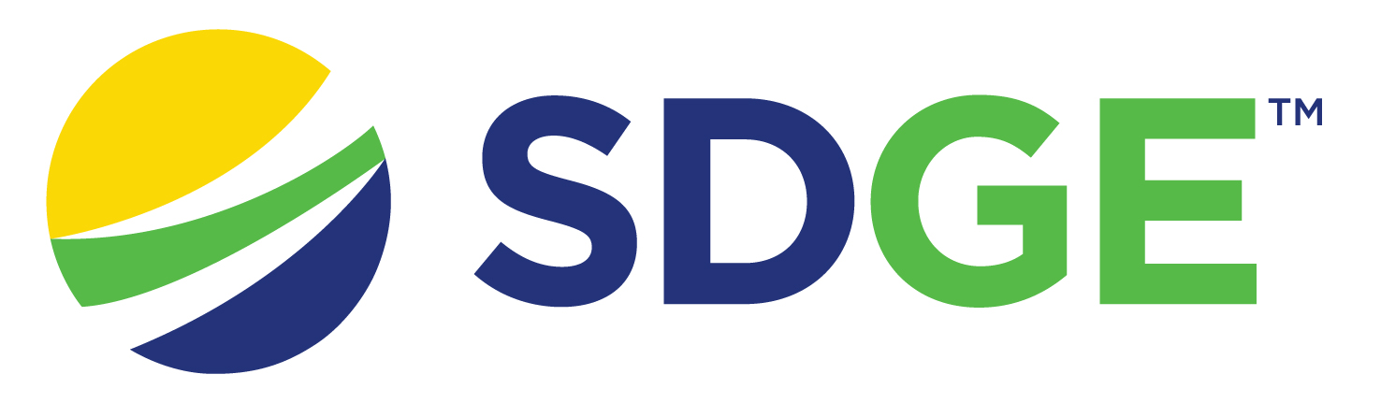

218731: Market Access Program Request for Proposals

Introduction
As part of San Diego Gas & Electric Company (SDG&E)’s solicitation schedule, and to comply with D.23.06-055, SDG&E is requesting Proposals for the Market Access Program. This is a one-stage solicitation process that will begin in May 2024. This Program will serve residential and the commercial retail, office, and wholesale sub-segment in the SDG&E service territory. This program will be classified as a Resource Acquisition program.
This solicitation will be conducted as a one-stage process. The Company is seeking EE program proposals (“Proposals”) from non-utility companies for the segment for the 2025-2027 program years (“Solicitation”). The objective of the solicitation is to implement Third-Party programs (“Programs”) that support the long-term success of the energy efficiency market by adhering to the cost-effectiveness guidance identified in D.23-06-055 and adhering to the market access guiding principles in D.23-02-002.
Bidders will be required to provide their Submittals to this RFP directly to SDG&E in accordance with the terms of this RFP. The Company will instruct Bidders in subsequent sections of this document on where and how to submit their Proposals. Please note that the information provided in the Proposal will be used as the basis of the initial draft contract if invited to contract negotiations.

Purpose and Objectives
The purpose of this RFP is to evaluate Proposals for program design and implementation services for the Market Access Program.
Key elements to consider when bidding on the Market Access Program RFP:
- Program Overview
- Program Design
- Program Operations
- Innovation
- Compliance
- Cost and Performance
- Experience and Capabilities

PowerAdvocate Registration
SDG&E will manage this event through Power Advocate’s sourcing platform. Interested bidders will need to register in Power Advocate to access all future communications and, upon its release, the RFP for the Market Access Program.
All Bidders are required to register in Power Advocate to access the RFP documents, submit questions, and submit the Market Access Program Proposals. Bidders can register in Power Advocate using the following URL: (https://www.poweradvocate.com). Apply to the event through the “Opportunities” portal, search for the SDG&E event, click the key to request access to the event.
Are you registering for a specific Event:* click the ‘Yes’ button
Who referred you to this Event:* PEPMA Announcement
Name of that individual’s company:* San Diego Gas & Electric Company
Name or description of the Event: 218731 Market Access Program
Click “Continue”

PowerAdvocate Support
Support@poweradvocate.com
(857)453-5800 M-F 8:00 AM to 8:00 PM Eastern Time

