- How will SDG&E allocate and recover its transportation electrification (TE) program and pilot costs?
  - Please identify the specific cost allocation factor that will be (is) used to allocate the TE costs using the cost allocation tables that are included in the revenue allocation settlement agreement and approved by D.17-08-030.

SDG&E Response:
As indicated in the Direct Testimony of SDG&E witness Kellen Gill, SDG&E’s proposal is to recover the costs of implementing the TE proposals within this application through the Distribution rate component. The current allocation factors associated with the Distribution rate component were approved in D.17-08-030, as a part of the Joint Motion to Adopt Revenue Allocation Settlement Agreement (“Joint Motion”), filed in SDG&E’s 2016 GRC Phase 2 application. Those factors can be found in Table 1 of that Joint Motion, which is also displayed below (See the last column, titled Settlement 2018). These are the same allocation factors provided below in response to Question 5a of this data request.

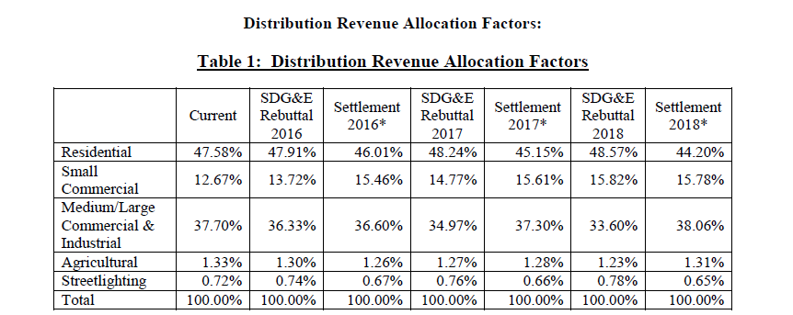

- Please confirm whether SDG&E’s proposal to collect program and pilot costs in distribution costs means that they would be non-bypassable.

SDG&E Response:

When considering departing load customers, SDG&E would consider these costs to be non-bypassable. However, when considering Net Energy Metering customers, these costs continue to be bypassable when they are collected as energy rates.

- Please provide the Transportation electrification
  - Investments requested and/or approved by the Commission between 2015 through 2018.
    - Provide a brief description about the project/investment requested.
    - Include application number and decision number if approved by the Commission.

 | Project Description | 2015 | 2016 | 2017 | 2018
A.XX-XX-XXX and D.XX-XX-XXX (if approved)
A.XX-XX-XXX and D.XX-XX-XXX (if approved)
A.XX-XX-XXX and D.XX-XX-XXX (if approved)
A.XX-XX-XXX and D.XX-XX-XXX (if approved)
Etc.
Total

  - Annual revenue requirement amounts between 2015 through 2025 associated with TE projects listed in 3.a. above. Include any remaining revenue requirements on rate-based assets the company intends to collect from ratepayers even after the conclusion of certain programs up to 2025. In doing so, please indicate the proceeding/decision (if applicable) those requests were made or approved according to the format below.

 | 2016 | 2017 | 2018 | 2019 | 2020 | 2021 | 2022 | 2023 | 2024 | 2025
D.16-01-045
A.17-01-020
A.18-01-012
Etc.
Total

SDG&E Response:
Please see Excel attachment titled, “ORA DR-003 Q3”.

- Please segregate the Transportation electrification investment into (i) “target” customer-dedicated equipment costs with loaders and inflation factors accounted for, (ii) non-customer-dedicated costs, and (iii) other (specify what they are) for SDG&E’s proposed program and pilot in this application (A.18-01-012).

Program Costs
 | $ Amount
Description | i | ii | iii
Electric Services
Transformers
Etc.

SDG&E Response:
The transportation electrification investments will be used to support EV adoption by the target customers. Items such as electric service and transformers will likely be dedicated to the EV load.

- Please provide all current allocation factors for
- Distribution;
- Generation;
- Generation with DA/CCA imputed;
- System average revenues;
- System average revenues with DA/CCA imputed as generation;
- System Sales;
- Bundled sales and;
- Non-Care Sales.

SDG&E Response:
Please note that only the Distribution and Generation percentages, shown below in response to Question 5 parts A and B are allocation factors approved in SDG&E’s most recent General Rate Case Phase 2. The remaining percentages shown below are simply the authorized sales or revenues, effective January 1, 2018.

  - Distribution
Residential | 44.20%
Small Commercial | 15.78%
Medium/Large Commercial & Industrial | 38.06%
Agricultural | 1.31%
Streetlighting | 0.65%
System | 100.00%

  - Generation
Residential | 42.83%
Small Commercial | 13.27%
Medium/Large Commercial & Industrial | 42.03%
Agricultural | 1.50%
Streetlighting | 0.37%
System | 100.00%

  - SDG&E’s Generation allocation factors are as detailed in response to Question 5b.
  - System average revenues (note: these revenues include those revenues included in SDG&E’s Class Average Rate calculation)
Residential | 42.61%
Small Commercial | 13.85%
Medium/Large Commercial & Industrial | 41.78%
Agricultural | 1.33%
Streetlighting | 0.43%
System | 100.00%

  - SDG&E’s system average revenues are as detailed in response to Question 5d.
  - System sales
Residential | 33.77%
Small Commercial | 11.61%
Medium/Large Commercial & Industrial | 52.62%
Agricultural | 1.56%
Streetlighting | 0.44%
System | 100.00%

  - Bundled Sales
Residential | 41.36%
Small Commercial | 14.11%
Medium/Large Commercial & Industrial | 42.24%
Agricultural | 1.76%
Streetlighting | 0.54%
System | 100.00%

  - Non-CARE Sales
Residential | 31.79%
Small Commercial | 11.97%
Medium/Large Commercial & Industrial | 54.16%
Agricultural | 1.63%
Streetlighting | 0.45%
System | 100.00%

- Does the revenue requirement amount of $220 million provided in Table GDS-11 include all depreciation and rate of return expenses (and others such as taxes) that ratepayers will still have to pay after the program’s conclusion in 2025?

  - If not, please provide the annual nominal amounts for the program and pilot including all overhead and loaders for the remaining economic lives of the assets installed. Please also include any nominal ongoing O&M costs for each.

SDG&E Response:
6. The amount of $220.8 million provided in Table GDS-11 represents the total Capital Expenditures and Operation and Maintenance expenses for the period 2019-2025. This does not represent the revenue requirement for the project. These costs in Table GDS-11 have been escalated and related overhead loaders and applicable sales tax. This table does not include depreciation and rate of return expenses (and other such taxes) after the program conclusion in 2025.

Table GDS-13 represents the revenue requirement for the project for years 2019-2025. Attached, as Excel document, “ORA DR-003 Q6”, is the expansion of GDS-13 that shows all depreciation and rate of return expenses (and other such taxes) over the life of the program assets. This amount is highlighted in yellow as is $719.7 million.

6.a. All capital and O&M costs including overhead loaders are included in GDS-11 as noted above. The attachment to Question 6 above also includes all depreciation, and rate of return (and other such taxes) beyond 2025 over the life of the program assets.

Prepared Direct Testimony of Kellen Gill, page KCG – 1, lines 14-15.
A. 15-04-012.
For pending applications, include SDG&E’s requested amounts, otherwise use the amounts authorized by the Commission.
A. 15-04-012, D. 17-08-030
Prepared Testimony of Gregory D. Shimansky on Behalf of San Diego Gas & Electric Company Chapter 5, page GDS-9.

